Checklist of E/OHS Activities for Respiratory Protection

Program Contact Person: Art Schweitzer

Does this school provide respirators for voluntary use? Yes No N/A
If the school allows employees to use respirators voluntarily the following is mandatory.
- Read and follow instructions provided by manufacturer.
- Choose respirators certified for use against contaminants of concern.
- Do not wear respirators in atmospheres containing contaminants not designed to protect from those contaminants.
- Keep track of respirators so that you do not mistakenly wear someone else’s respirator.

Is the Respiratory Protection program in place? Yes No N/A

Is the Plan current? Yes No N/A

Has the Plan been reviewed this school year? Yes No N/A

Date of review: _Sept, 2010

Are all employees in this program identified? Yes No N/A

Employee | Intended Use | Type of Respirator | Medical Exam/  Questionnaire | Date of Medical | Date of  Fit Test
Art Schweitzer | Misc. voluntary | ½ Mask | yes | 1/2009 | 1/2009

Fit testing was completed on N/A.
(date)

Type of testing protocol; Irritant Smoke (Stannic Chloride) or
Bitrex (Denatonium Benzoate)

Condition and location of respirators:

Condition: Good condition

Location(s): In metal cabinet next to desk in boiler room.

Are the appropriate adequate accessories on hand? Yes No N/A

Verified by Lee Carlson

Respirator Equipment Inventory

 |  |  |  |  | Cartridges
Respirator Type | Respirator  Brand | Location | Valve  Flaps? | Straps? | Organic | Particulate | Combination
PAPR Power Flow
PAPR Power Flow
½ mask | AOS | Boiler room | yes | yes |  | yes
½ mask
½ mask
Full face | Wilson | Boiler room | yes | yes | yes
Full face

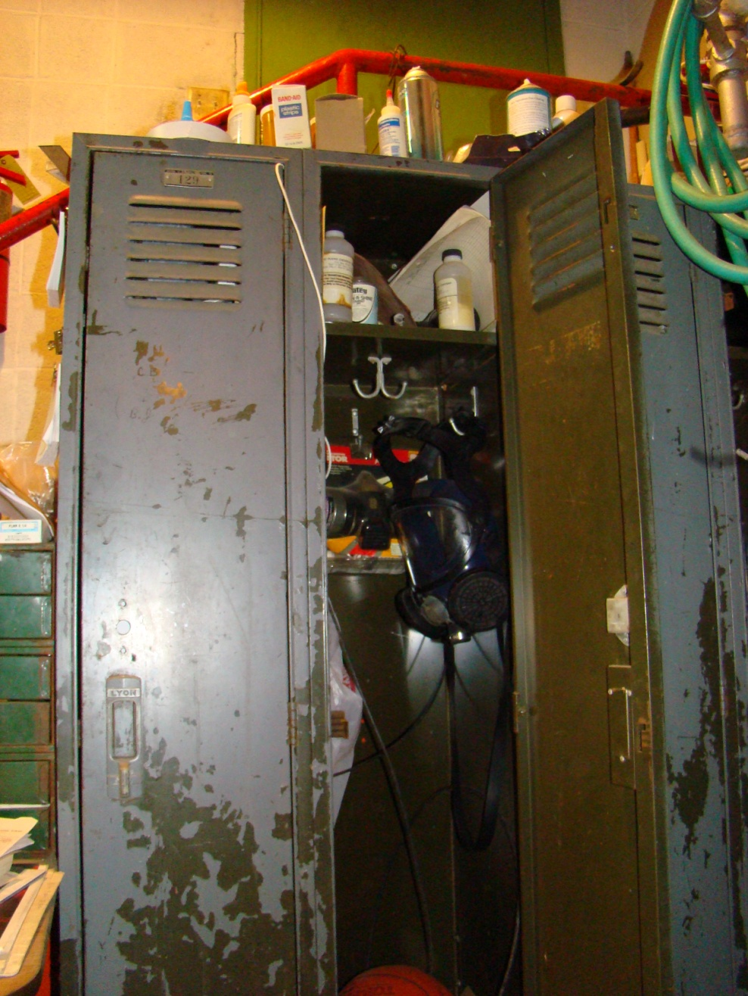

The respirators were cleaned and checked 1-4-10. LC
Art is no longer fit checked and having physicals completed as a requirement of the local fire department. Future use will be on a voluntary basis.1-4-10

